Colliding BECs – simulation of classical binary collisions
A summary of the classical simulation of BEC FWM experiment at ANU He* BEC lab is presented here.
Scope of simulation
The classical model is an elastic binary collision of point-like particles from colliding condensate sources which undergo s-wave scattering. The sources have identical momentum distribution (other than the mean collision momentum) calculated from the Thomas-Fermi approximation of trapped BEC. For simplicity, the analytical TF momentum distribution is approximated by a 3D Gaussian by matching the HWHM (1.99/R_{i} from analytical solution). The model further assumes that momenta of the collision pairs are independent, except for the condition that they may not be both from the same source. Collision velocity in the centre of mass frame has been set to hbar*k/m_{He}, which resembles our experiment (1083nm laser for Bragg/Raman transitions).
The input simulation parameters relevant to the experiment are the condensate population, trap frequencies, detector quantum efficiency, and the number of scattered atoms detected.
Comparisons of the width of the scattering halo (w^{(H)}) is made to the g² correlation length of back-to-back momentum pairs (g⁽²⁾_{BB}) and source momentum width (w^{(S)}).

Methods
From the Thomas-Fermi approximation, the momentum widths of the sources are determined. Collision pairs in momentum space are repeatedly generated from random selection and each particle is randomly selected for detection at the quantum efficiency, until the set number of scattered atoms are met (30 atoms per halo). When the simulation has been repeated for a sufficient number of times (5000 halos), the collated set of scattered atoms in momentum space show the familiar s-wave scattering halo from many experiments. Projected g⁽²⁾_{BB,i} correlations are fitted well by 1D Gaussians and compared with the momentum widths of the halo and the source condensate.

Results
Summary for a weak {48,180,180}Hz, and strong trap {50,500,500}Hz†

* Table of results‡
Trap | Weak | Strong
w_{i}^{(S)} | 0.0086, 0.0324, 0.0324 | 0.0059, 0.0593, 0.0593
w^{(H)} | 0.0348 | 0.0629
w(g⁽²⁾_{BB,i}) | 0.0151, 0.0574, 0.0572 | 0.0109, 0.1471, 0.1483

* Scattering halo
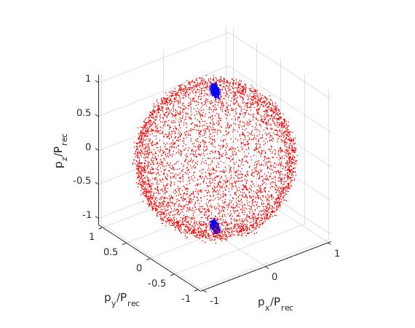 | 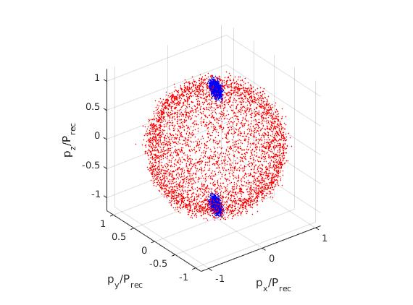

* Halo momentum distribution
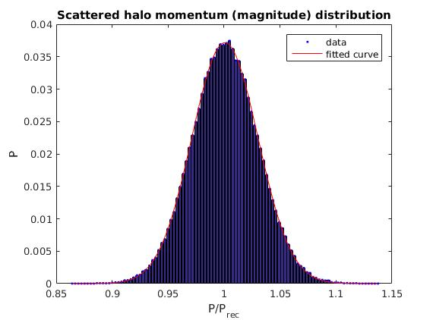 | 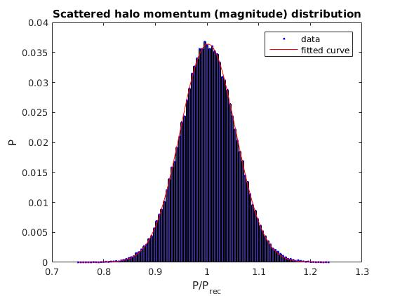

* g⁽²⁾_{BB}
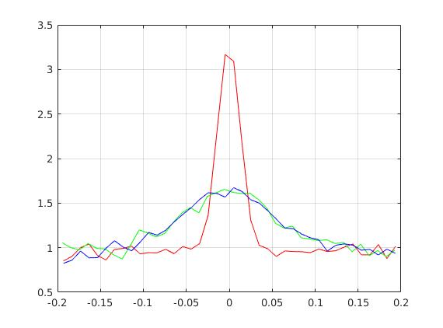 | 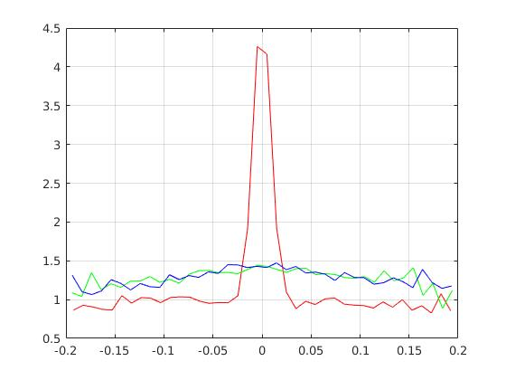
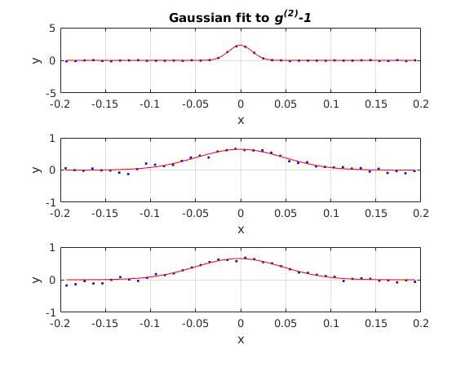 | 